Tables & Records for SQL Mandatory Assignment 1 & 2

**Salesman Table**

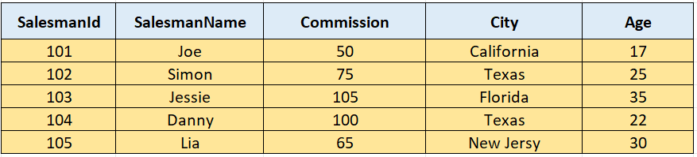

**Salesman table creation**

CREATE TABLE Salesman (

SalesmanId INT,

Name VARCHAR(255),

Commission DECIMAL(10, 2),

City VARCHAR(255),

Age INT

);

**Salesman table record insertion**

INSERT INTO Salesman (SalesmanId, Name, Commission, City, Age)

VALUES

(101, 'Joe', 50, 'California', 17),

(102, 'Simon', 75, 'Texas', 25),

(103, 'Jessie', 105, 'Florida', 35),

(104, 'Danny', 100, 'Texas', 22),

(105, 'Lia', 65, 'New Jersey', 30);

**Customer Table**

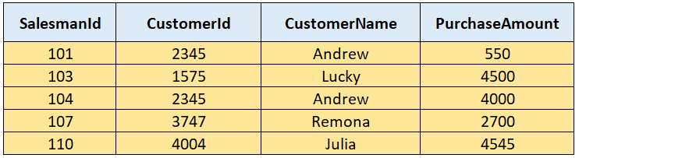

**Customer table creation**

CREATE TABLE Customer (

SalesmanId INT,

CustomerId INT,

CustomerName VARCHAR(255),

PurchaseAmount INT,

);

**Customer table record insertion**

INSERT INTO Customer (SalesmanId, CustomerId, CustomerName, PurchaseAmount)

VALUES

(101, 2345, 'Andrew', 550),

(103, 1575, 'Lucky', 4500),

(104, 2345, 'Andrew', 4000),

(107, 3747, 'Remona', 2700),

(110, 4004, 'Julia', 4545);

**Orders Table**

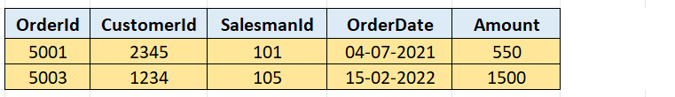

**Orders table Creation**

CREATE TABLE Orders (OrderId int, CustomerId int, SalesmanId int, Orderdate Date, Amount money)

**Orders table record insertion**

INSERT INTO Orders Values

(5001,2345,101,'2021-07-01',550),

(5003,1234,105,'2022-02-15',1500)